SOC Practical Application Report
Document Version: 1.0

Document Information
Item | Details
Assessment Type | SOC Monitoring and Brute-Force Detection using SIEM
Tools Used | Windows Event Viewer, Splunk, Wazuh SIEM, Elastic SIEM, LogParser Lizard
Target Scope | Windows10VM-(192.168.1.9)  Ubuntu VM-(192.168.1.8)
Report Prepared By | Atharva Balwadkar
Date | 27-02-2026

Introduction
This report documents the practical implementation of Security Operations Center (SOC) monitoring activities conducted within a controlled lab environment. The objective of this exercise was to simulate real-world security monitoring scenarios, including brute-force detection, log analysis, browser artifact investigation, dashboard creation, and alert rule configuration.
The lab environment was built using Windows and Ubuntu virtual machines integrated with SIEM platforms. The exercises demonstrate how SOC analysts detect, investigate, and document suspicious authentication attempts and system-level activities using structured workflows and standardized monitoring tools.
This documentation serves as academic evidence of practical SOC capability and understanding of detection engineering concepts.

1. Log Analysis Practice
1.1 Windows Event Log Monitoring
Windows Event Viewer was used to monitor security-related logs.
The following Event IDs were analyzed:
- Event ID 4625 – Failed Login Attempt
- Event ID 7045 – New Service Creation

Procedure:
- Open Event Viewer
- Navigate to: Windows Logs → Security
- Apply filter for Event ID 4625
- Review login failure patterns
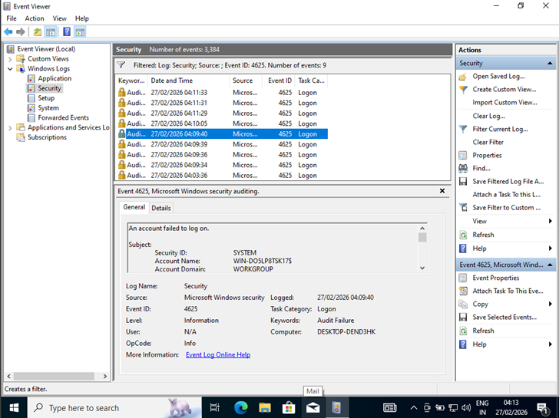
Observations:
Multiple failed log in attempts from the same source IP within a short time period were identified. This pattern indicates a potential brute-force authentication attack.
Event ID 7045 was also reviewed to detect unauthorized service installations that may indicate persistence mechanisms.

1.2 Browser History Analysis
Browser artifacts were analyzed using Eric Zimmerman’s forensic tool (LECmd).
Objective:
To detect visits to a test URL
Procedure:
- Located Chrome history database file
- Parsed file using LECmd
- Extracted visited URLs and timestamps

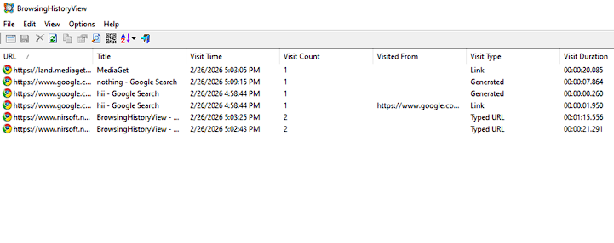
Outcome:
The test URL was successfully identified in the browser history output, demonstrating forensic investigation capability within endpoint monitoring scenarios.

1.3 Advanced Task: Brute Force Detection
Failed login attempts were generated in a Windows Virtual Machine using repeated incorrect password entries.
The security logs were:
1. Filtered using Event Viewer for Event ID 4625
2. Exported into CSV format
3. Analyzed for brute-force attack indicators

Steps Performed:
- Generated repeated login failures
- Filtered logs using Event ID 4625
- Observed timestamps and source IP
- Exported filtered logs into CSV format
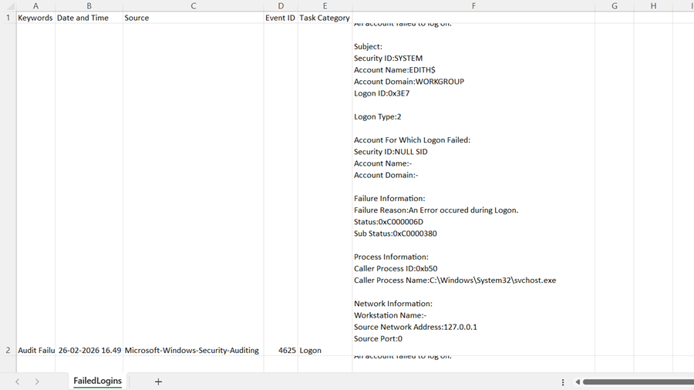
Result:
The exported logs clearly showed multiple authentication failures originating from the same IP address within a short time frame, confirming brute-force behavior.

2. Security Event Documentation
Security events were recorded using a structured SOC documentation template to maintain consistency in log tracking and incident analysis.
Security events were documented using the following template:
Date | Source ip | Event ID | Description | Action Taken
27-02-26 | 192.168.1.9 | 4625 | Multiple Failed Login Attempts | Alert Reviewed & Logged

Importance of Documentation:
- Maintains investigation timeline
- Ensures audit compliance
- Supports incident response tracking
- Assists in future forensic review

3. Monitoring Dashboard Setup
Security monitoring dashboards were configured in Splunk to visualize authentication patterns.
1. Top 10 Source IPs Generating Alerts
Displayed IP addresses with highest failed login attempts.
2. Frequency of Critical Event IDs
Tracked repeated occurrences of Event ID 4625.
Outcome:
The dashboards provided visual insight into abnormal login trends and helped quickly identify suspicious IP activity.
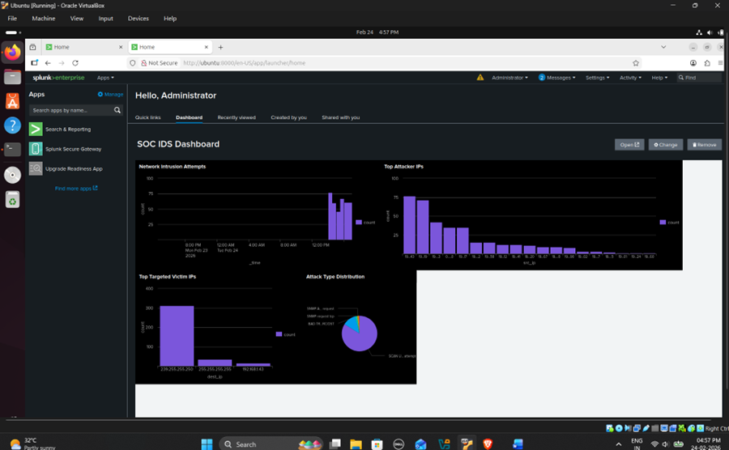

4. Alert Rule Configuration
4.1 Splunk Alert Rules Configuration
Snort Rule Created: Detect 5+ failed logins in 5 minutes
Index: security-login-*
Condition: count > 5
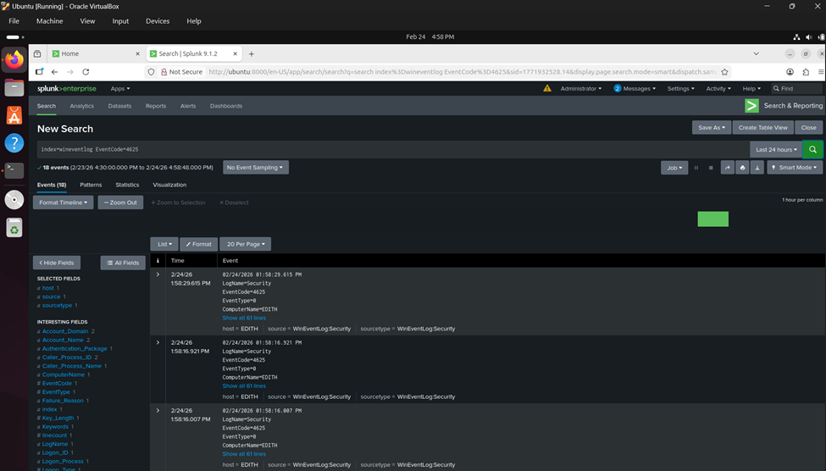

4.2 Advanced Task: SSH Brute Force Detection using Wazuh SIEM
A simulated SSH brute-force attack was performed from a Windows host to an Ubuntu server using invalid login credentials.
The Wazuh SIEM platform was configured to monitor authentication logs from:
• /var/log/auth.log (Ubuntu Endpoint)
Repeated unauthorized login attempts generated security events which were successfully detected by the built-in Wazuh rule.
The generated alert details are as follows:
- Rule ID: 5710
- Description: sshd: Attempt to login using a non-existent user
- Agent Name: ubuntu
- Severity Level: 5
- Source IP: 192.168.0.8
This indicates multiple unauthorized SSH login attempts which may represent brute-force credential attacks.
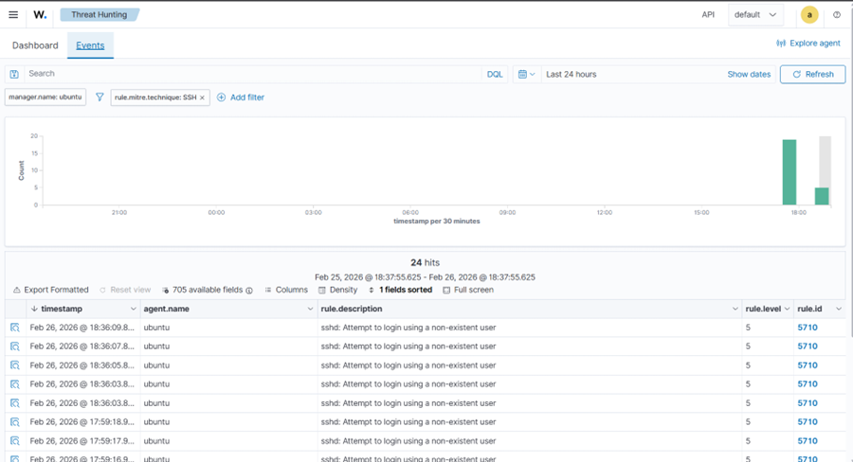

5. MITRE ATT&CK Mapping
Detected brute-force activity was mapped to:
- Tactic: Credential Access
- Technique: T1110 – Brute Force
This mapping confirms that repeated authentication failures align with adversarial brute-force techniques commonly used in real-world attacks.
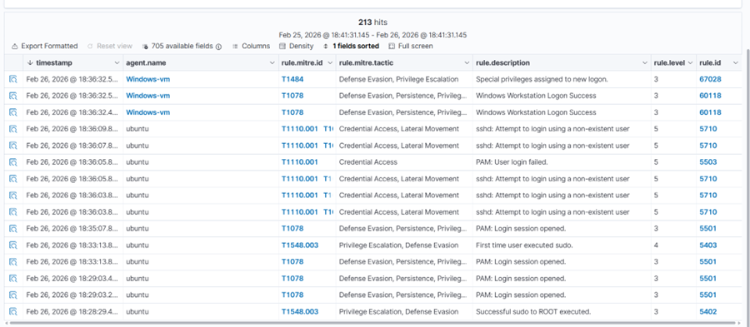

6. SOC Workflow Implementation
The following SOC workflow was followed during the exercise:
- Detection – Alert triggered in SIEM
- Triage – Verified repeated failed login pattern
- Investigation – Correlated logs and timestamps
- Response – Documented event and monitored source IP
- Reporting – Exported logs and recorded findings
This structured workflow ensures consistent incident handling procedures.

Conclusion
The practical SOC lab successfully demonstrated:
- Log filtering and analysis
- Brute-force attack simulation
- Alert rule creation and validation
- Dashboard visualization
- Browser forensic artifact analysis
- Structured security documentation
The exercises replicate real-world SOC monitoring operations and provide foundational experience in threat detection, investigation, and reporting within a controlled environment.

References
- Splunk Documentation
- Wazuh Documentation
- MITRE ATT&CK Framework

